Never Forgotten Honor Flight
May 21, 2018 Itinerary
 | ALL TIMES ARE "LOCAL" TIMES
 | 4:30 AM |  |  |  | GUARDIANS check in
 | 5:00 – 5:30 AM  5:50 |  |  |  | VETERANS check in (snacks, coffee provided at gate)  Load aircraft
 | 6:30 AM |  |  |  | Sun Country Flight #8600 departs CWA (breakfast sandwich on plane)
 | 9:30 AM |  |  |  | Arrive Reagan (bathroom break)
 | 10:35 AM |  |  |  | Depart Reagan in Motor Coach
 | 10:50 AM |  |  |  | Arrive at Korean, Vietnam, and Lincoln Memorials (Group Photo)
 | 1:05 PM |  |  |  | Depart Memorials
 | 1:05 – 1:30 PM |  |  |  | BUS TOUR (Capitol; Navy Memorial; White House)(box lunch on bus)
 | 1:30 PM |  |  |  | Arrive WWII Memorial
 | 3:05 PM |  |  |  | Depart WWII Memorial (snack bars)
 | 3:20 PM |  |  |  | Arrive Arlington National Cemetery
 | 4:00 PM |  |  |  | Changing of the Guard at the Tomb of the Unknown Soldier.
 | 4:30 PM Depart  4:45-5:30 PM |  |  |  | 911 Memorial
5:45 PM |  |  |  | Arrive Air Force Memorial (Dinner)
 | 7:05 PM |  |  |  | Depart Memorial
 | 7:20 PM |  |  |  | Arrive Reagan Airport
 | 8:45 PM |  |  |  | Sun Country Flight #8601 departs Reagan
 | 9:55 PM |  |  |  | Arrive Wausau (arrival at CWA dependent on weather/unexpected delays)
 |  |  |  |  | 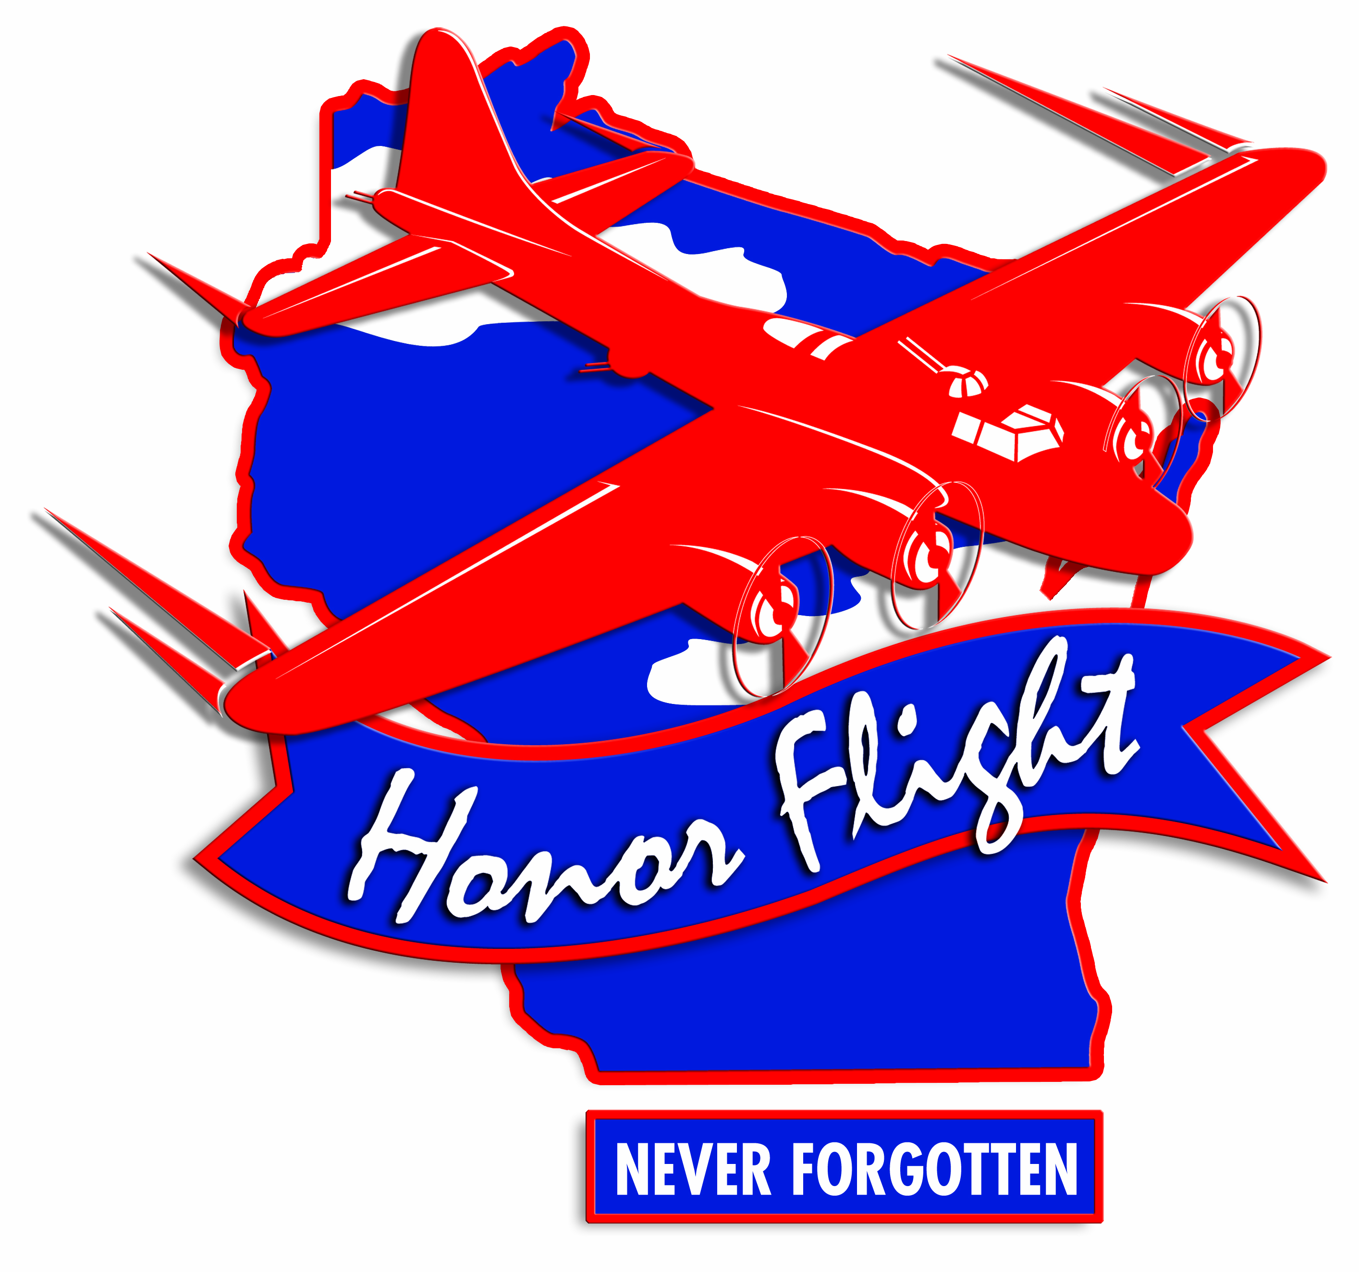
Rev. 22 February 2018

