Never Forgotten Honor Flight

October 15, 2018 Itinerary

ALL TIMES ARE “LOCAL” TIMES

4:30 AM GUARDIANS check in
5:00 – 5:30 AM VETERANS check in (snacks, coffee provided at the gate)
6:00 AM Load aircraft
6:45 AM Sun Country Flight # 8663 departs CWA (morning snack on the plane)

9:45 AM Arrive Reagan (bathroom break)
10:50 AM Depart Reagan in Motor Coach

11:05 AM Arrive at Korean, Vietnam, and Lincoln Memorials (Group Photo)
1:05 PM Depart Memorials

1:05 -1:25 PM BUS TOUR: Capitol; Navy Memorial; White House (box lunch on bus)

1:25 PM Arrive at WWII Memorial
2:35 PM Depart WWII Memorial

2:40 PM Arrive at FDR Memorial (snack bars)
3:25 PM Depart FDR

3:35 PM Arrive at Arlington National Cemetery
4:00 PM Changing of the guard at the Tomb of the Unknown Solder
4:45 PM Depart ANC

4:55 PM Arrive at Iwo Jima
5:35 PM Depart Iwo

5:55 PM Drive by Pentagon/9-11 Memorial. Arrive at the Air Force Memorial (dinner)
7:30 PM Depart AF Memorial

7:40 PM Arrive at Reagan Airport
9:00 PM Sun Country Flight # 8664 departs Reagan

10:10 PM Arrive Wausau (arrival at CWA dependent on weather/unexpected delays)

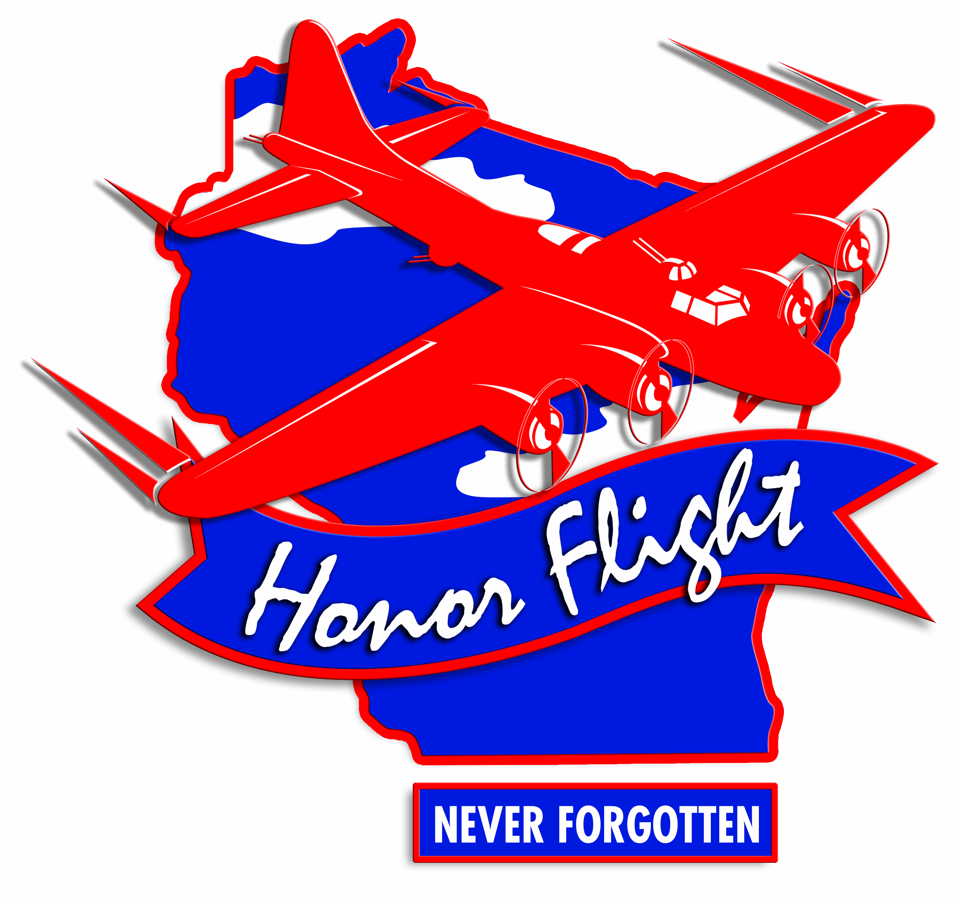Rev 17 July, 18

