Never Forgotten Honor Flight
April 8, 2019 Itinerary
ALL TIMES ARE "LOCAL" TIMES
4:30 AM |  | GUARDIANS check in
5:00 - 5:30 AM  6:00 AM |  | VETERANS check in (snacks, coffee provided at gate)  Load aircraft
6:45 AM |  | Sun Country Flight # 8601 departs CWA (morning snack on plane)
9:45 AM |  | Arrive Reagan (bathroom break)
10:50 AM |  | Depart Reagan in Motor Coach
11:05 AM |  | Arrive WW II Memorial (Group Photo)
12:40 PM |  | Depart WW II Memorial
12:40–1:05 PM |  | BUS TOUR (Capitol; Navy Memorial; White House)(box lunch on bus)
1:05 PM |  | Arrive Korean, Vietnam, and Lincoln Memorial
2:50 PM |  | Depart Korean Memorial
2:55-3:35 PM |  | FDR Memorial (snack bars)
3:50 – 4:20PM |  | Iwo Jima
4:30 PM |  | Arrive Arlington National Cemetery
5:40 PM |  | Changing of the Guard at the Tomb of the Unknown Soldier, Depart ANC
5:55 PM |  | Arrive Air Force Memorial and Drive By Pentagon / 9-11 Memorial (Dinner)
7:30 PM |  | Depart Memorial
7:40 PM |  | Arrive Reagan Airport
9:00 PM |  | Sun Country Flight # 8602 departs Reagan
10:10 PM |  | Arrive Wausau (arrival at CWA dependent on weather/unexpected delays)
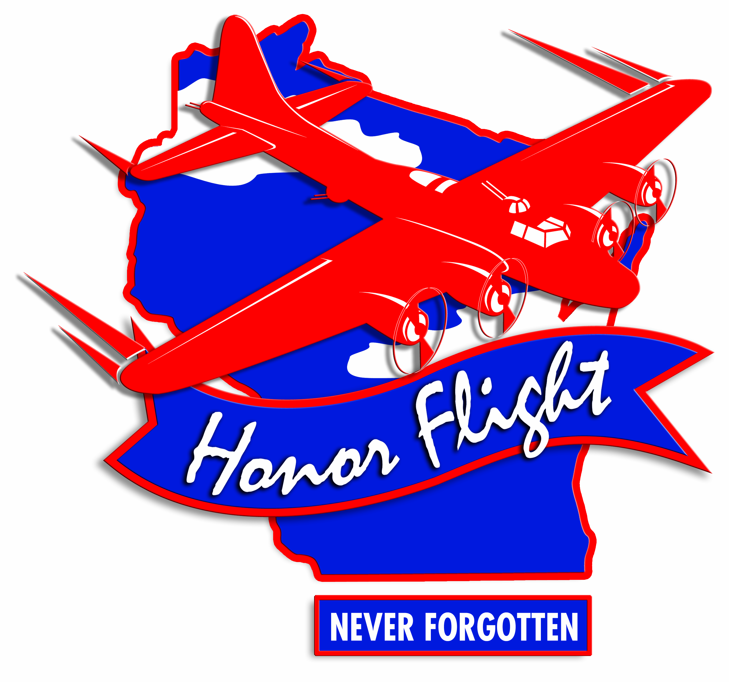^{REV 1 February 2019}

