Never Forgotten Honor Flight
May 13, 2019 Itinerary
ALL TIMES ARE "LOCAL" TIMES
4:30 AM |  | GUARDIANS check in
5:00 - 5:30 AM  6:00 AM |  | VETERANS check in (snacks, coffee provided at gate)  Load aircraft
6:45 AM |  | Sun Country Flight # 8601 departs CWA (morning snack on plane)
9:45 AM |  | Arrive Reagan (bathroom break)
10:50 AM |  | Depart Reagan in Motor Coach
11:05 AM |  | Arrive Korea, Vietnam, and Lincoln Memorial (Group Photo)
1:00 PM |  | Depart Korea, Vietnam, and Lincoln Memorial
1:05 PM |  | Arrive FDR Memorial (box lunch)
1:55 PM |  | Depart FDR
2:00 PM |  | Arrive WWII Memorial
3:20 PM |  | Depart WWII Memorial
3:40 PM |  | Arrive at Iwo Jima (Snack)
4:15 PM |  | Depart Iwo Jima
4:30 PM |  | Arrive at Arlington National Cemetery
5:45 PM |  | Changing of the Guard at the Tomb of the Unknown Soldier
6:00 PM |  | Arrive at Air Force Memorial and drive by Pentagon/9-11 Memorial (Dinner)
7:30 PM |  | Depart Memorial
7:40 PM |  | Arrive Reagan Airport
9:00 PM |  | Sun Country Flight #8602 departs Reagan
10:10 PM |  | Arrive Wausau (arrival time at CWA dependent on weather/unexpected delays)

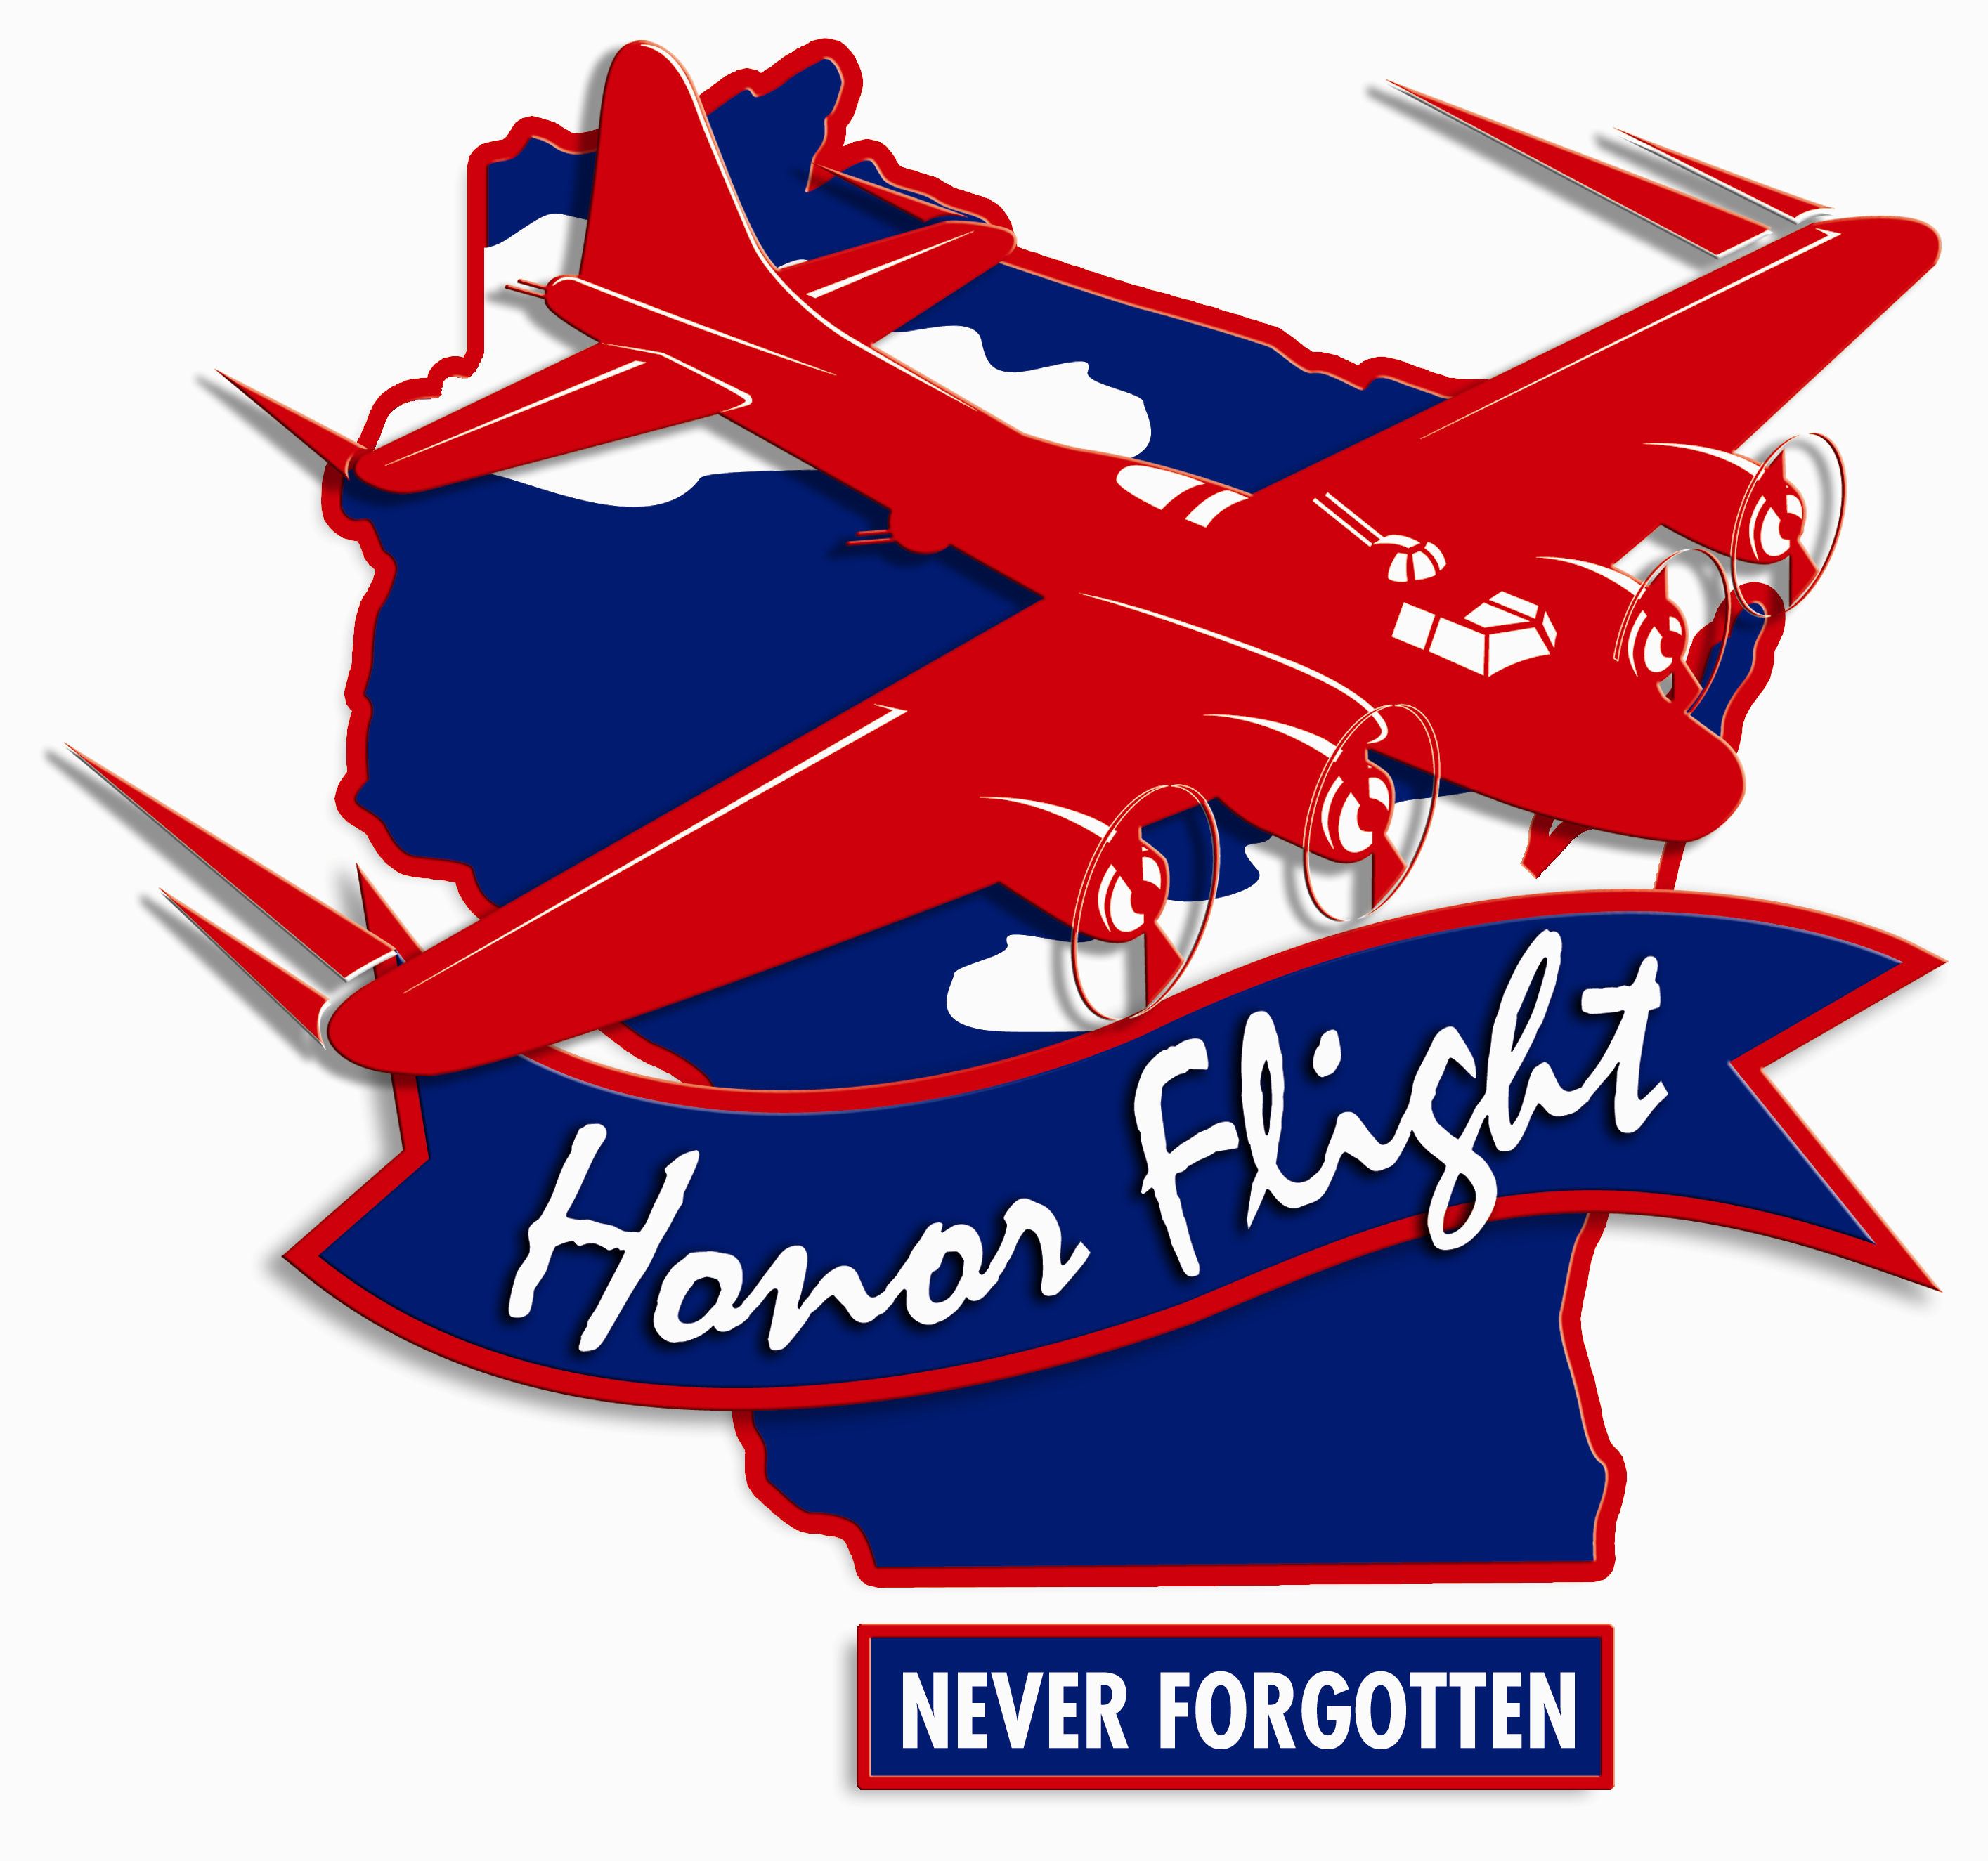Rev. 27 Feb 2019

