11th Annual Deerbrook Rumble
Motorcycle Ride on Aug. 5th 2023
And ATV & UTV Poker run
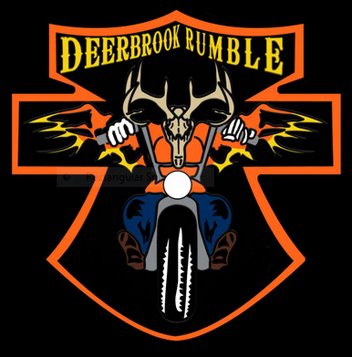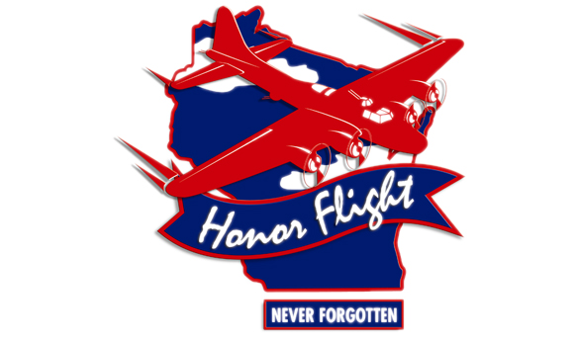
Proceeds go to Never Forgotten Honor Flight!!
Ride will start at Held’s Bar in Deerbrook WI. Intersection of County Rds. H, I & C. in Langlade County. Bar will open at 9:30 am to take registration; cost is $25 per bike & $5 for a passenger. Motorcycles will depart at 11:00am. and returning to MC Festival Grounds by 5:30 pm for fun, raffles and live music staring 8:00pm to 12:?? (Band Honky Tonk Highway). Free primitive camping is available so everyone can have fun and enjoy the party!! ATV’s and UTV’s will have multiple starting places and return at 5:30 pm to MC Festival Grounds. Please contact Fisher’s bar for details.
For more information contact, Held’s Bar @ 715-623-2743
Kevin Ashby @ 715-627-2121 or kb.team98@hotmail.com
ATV & UTV contact Fisher’s Bars (715) 873-4561
Maps & directions available if needed.
Like us on Facebook!

