Dear friend of the Never Forgotten Honor Flight,

One of the fascinating parts of our Honor Flight experience is learning about the memorials that we visit. Each is rich in symbolism that goes far beyond what the casual observer would discover.

The World War II Memorial honors the service of 16 million members of the Armed Forces of the United States of America, the support of countless millions on the home front, and the ultimate sacrifice of 405,399 Americans.

One of those veterans honored by the memorial is the late Senator Bob Dole. He and his wife, Senator Libby Dole, championed the building of the WWII Memorial. Bob was wounded in action leading troops into combat in Italy in April of 1945. Paralyzed from the neck down, he lay where he fell for 10 hours before being picked up and taken to a field hospital. Multiple surgeries and rehab over 39 months allowed him to walk again, but he never regained function in his right arm.

Bob and Libby loved veterans and enjoyed welcoming Honor Flights to the memorial when the US Senate was not in session, generally on weekends. Because we fly on Mondays, we always missed out on seeing the Doles – until we flew on Labor Day in 2019. On our way out of the WWII Memorial, there they were, personally greeting our veterans and thanking them for their service.

It's not often that you get to meet one of your heroes, let alone two of them. But the veterans and guardians of Flight #37 got to meet two heroes that day. And the Doles got to meet 108 more as they greeted the gold shirts of the Never Forgotten Honor Flight.
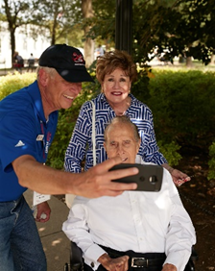
Thank you for all you do to make meetings like this possible.

Here’s a look at our scoreboard as it stands today:
Veterans flown |  |  |  | Waiting list
WWII | Korea | Vietnam | Total | WWII | Korea | Vietnam | Total
1,046 | 1,260 | 2,302 | 4,608 | 0 | 4 | 614 | 618

For the heroes,
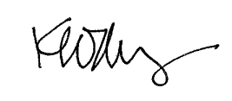
Ken Moberg
President
Never Forgotten Honor Flight

