Dear friend of the Never Forgotten Honor Flight,

I’ll never forget the night my family and I walked through the Korean War Veterans Memorial in Washington DC.  The scene was quiet and deserted, save my family and the 19 larger-than-life figures on their endless patrol.  The footlights shining up on them gave the eerie effect of something my siblings and I did when we wanted to scare one another: hold a flashlight under your chin in the dark and shine it up your face.  I almost expected to hear the voice of my brother saying “Boo!”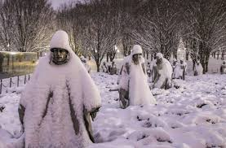As with the other memorials in Washington DC, this one is full of symbolism.  The 19 figures walk on patrol through juniper bushes and polished granite, representing the rice paddies of Korea.  The 14 soldiers, 3 marines, 1 sailor and 1 airman show the mix of American forces in Korea, and their faces depict the ethnic blend of those forces.  The figures walk uphill wearing windblown ponchos to depict the harsh conditions of the conflict.  The polished granite wall to their right is etched with the faces of 2,400 men and women who fought in this war.  The reflection of the members of the patrol on that wall doubles their number to 38, symbolizing the 38 months of the war as well as the 38th Parallel, the final line of demarcation between North and South Korea.

A reflecting pool at the tip of the patrol is marked with the words, “Freedom is not free.”  At the point of the triangle leading to the American flag is a dedication stone, which reads: “Our nation honors her sons and daughters who answered the call to defend a country they never knew and a people they never met.”  In July of 2022, a wall of remembrance was added, including the names of the 36,574 American servicemen and women who gave their lives in this conflict.

The Korean War Veterans Memorial is one of the many places the Never Forgotten Honor Flight goes to count the cost of freedom and to honor our veterans.  Thanks for your part in making the “Trip of a Lifetime” possible.

Here’s a look at our scoreboard as it stands today, before our fall flights:

|  |  |  |  |  |  |  |  |
| --- | --- | --- | --- | --- | --- | --- | --- |
| **Veterans flown** | | | | **Waiting to fly** | | | |
| WWII | Korea | Vietnam | Total | WWII | Korea | Vietnam | Total |
| 1,046 | 1,260 | 2,302 | 4,608 | 0 | 8 | 657 | 665 |

 For the heroes,

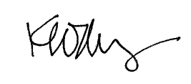

Ken Moberg

President

Never Forgotten Honor Flight