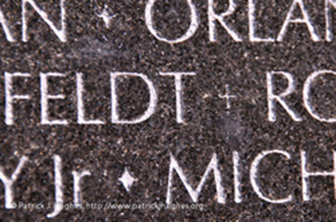

Dear friend of the Never Forgotten Honor Flight,

On the Vietnam Veterans Memorial (generally called the Vietnam Wall), you’ll find the names of the 58,273 men and 8 women who died or went missing in the Vietnam War. Next to their names, you’ll find either a diamond or a cross. The diamond means the person was killed in action (KIA). The cross means the person went missing (MIA) or was a prisoner of war (POW), but has not been found.

I met Al Shine, then a major, when I served in the 101st Airborne Division in the 1970’s. Al was one of four siblings who went to Vietnam. He and another of his brothers were infantry officers, one brother was an Air Force pilot, and the sister was an Army nurse. Al’s two brothers did not return alive. Al went on to serve 27 years in the Army, and was awarded the Silver Star, the Legion of Merit, and the Purple Heart.

The names of Al’s two brothers are etched into the polished marble of the Vietnam Wall.

The first brother, Army 1LT Jonathan Shine, was a USMA graduate, Airborne, Ranger, who served his country as an infantry officer. He was killed in Vietnam on Oct 15, 1970 and awarded the Silver Star. He is buried at West Point. His name on the wall is inscribed next to a diamond, signifying Killed in Action (KIA).

Al’s other brother, Air Force LTC Anthony Shine, was shot down over Laos while piloting an A7D Corsair II on a helicopter escort mission in December 1972. At that time, he was declared Missing in Action (MIA), and his name on the Vietnam Wall was marked with a cross. In 1993, his daughter traveled to Vietnam to visit the crash site. She met a man there who had her father’s flight helmet, with his name hand-written inside. On August 2, 1996, Tony’s remains were positively identified, and his status was changed to Killed in Action (KIA). The cross next to his name on the Wall was only changed to a diamond.

One family. Four heroes.

Thanks for helping us honor all the heroes who served, whether in country or not, in combat or not. “All gave some, some gave all.”

For the heroes,

Ken Moberg

President

Never Forgotten Honor Flight